Analyzing Techniques and Performance Trends in Brazilian

Jiu Jitsu Competitions: A Visual Approach

Steve Meadows
Grand Valley State University


Abstract

This project explores the performance and techniques of Brazilian Jiu Jitsu (BJJ) athletes competing at the Abu Dhabi Combat Club (ADCC) tournaments using visualization techniques. By analyzing two publicly available datasets, we identify the most effective submissions, trends across weight classes, and performance patterns over time. Targeting competitive practitioners and coaches, the dashboards provide actionable insights into submissions, win rates, and global participation. Key visualizations include submission analysis, performance metrics, and fighter distributions, enabling users to optimize training strategies and better understand high-level competitive BJJ. diam.

Index terms: Sports analytics, data visualization, Brazilian Jiu Jitsu, performance analysis, interactive dashboards.
* e-mail: meadoant@mail.gvsu.edu

Introduction
Brazilian Jiu Jitsu (BJJ) is a grappling martial art emphasizing submissions over strikes, and its competitive scene has grown globally, with the ADCC tournament being its pinnacle. For athletes and coaches, identifying trends in techniques and understanding performance metrics are crucial for achieving success.

This project leverages data visualization to analyze BJJ competitions. Using datasets from Kaggle, we visualize submission trends, performance metrics, and global participation. The project focuses on answering key research questions that benefit competitive practitioners and coaches.

Tasks and Reasearch Questions
The project addresses the following tasks:
- Identifying the most effective submissions across weight classes and time periods.
- Analyzing performance trends: win rates, match outcomes, and fighter success metrics.
- Exploring global fighter distribution and its relationship with submission specialization.

Data Sources
Two datasets were utilized:

- ADCC Historical Dataset: Match data including submissions, outcomes, and timelines.
- ADCC Fighter Stats: Detailed fighter statistics such as weight class and win rates.

Visualization Design

Visualization 1: Submissions by Weight Class
Purpose: Identify prevalent submissions and their success rates.
Components:
- Pie Chart: Shows submission proportions overall.
- Line Chart: Tracks trends (e.g., leg locks) over time.
- Stacked Bar Chart: Breaks down submissions by year and category.
Insights: Trends reveal the rise of leg locks in modern competition and differences across weight classes.

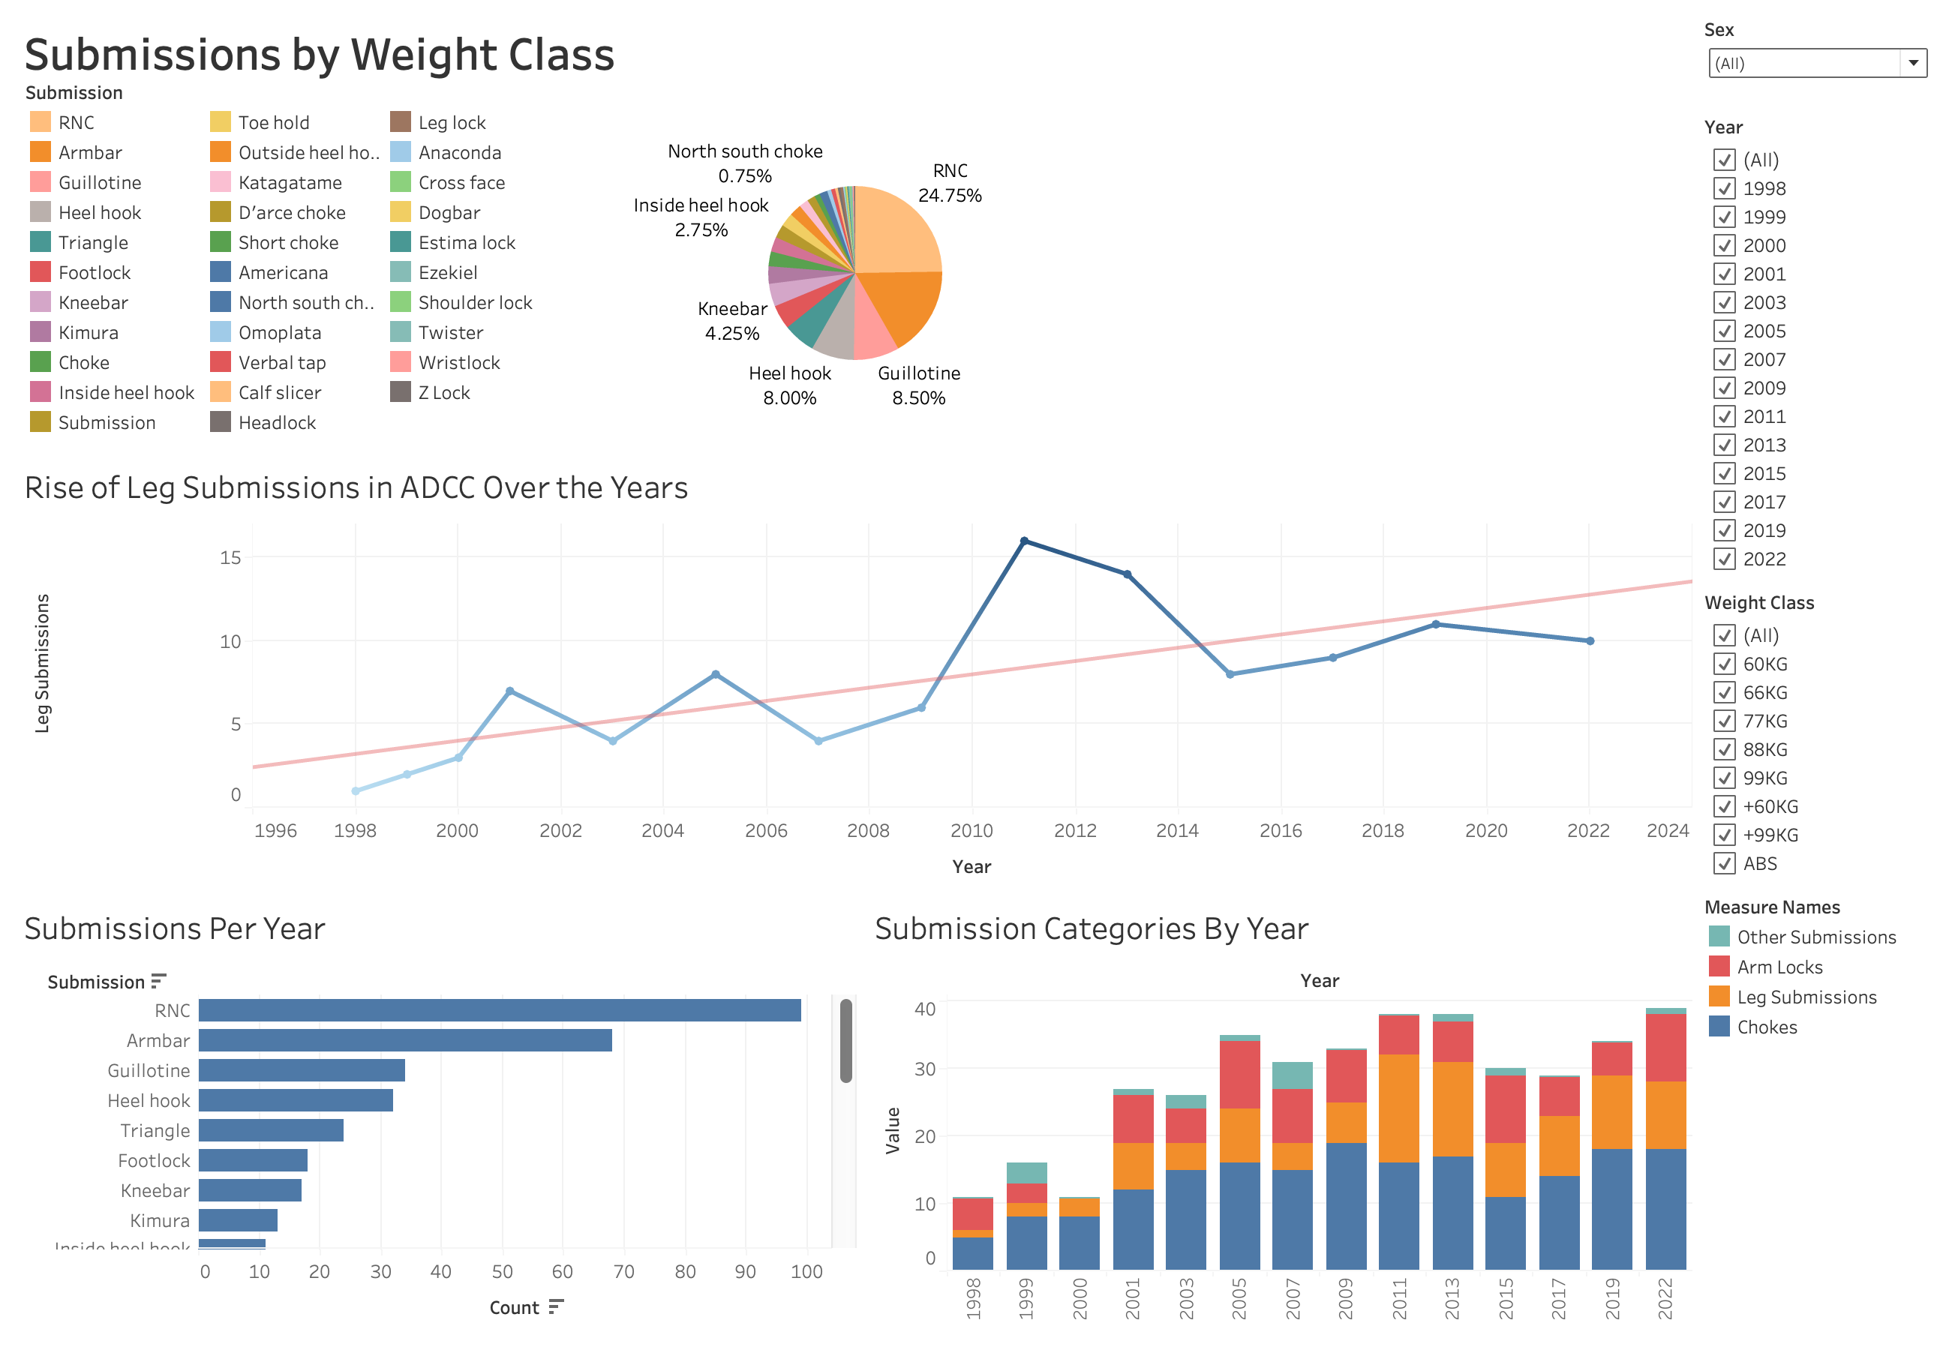

Design Process

Submissions by Weight Class

To provide both coaches and fighters with a comprehensive understanding of the landscape of submissions in ADCC competitions, I created a pie chart displaying the total proportion of submissions that successfully led to victories. This visualization allows users to assess which submission techniques have been the most dominant across the history of the tournament.

By visualizing the overall distribution, users can:

- Identify high-percentage techniques that consistently lead to success.
- Compare the relative frequency of different submission types to better inform their strategies and training focus.

The simplicity of the pie chart ensures accessibility for users of varying analytical skills while delivering key insights into what works and what doesn't at the highest levels of competition.

I color-coded each submission type and provided a legend for clarity. I also ordered the pie chart in descending order, going counter-clockwise, to make the most significant proportions immediately visible. Additionally, I included labels to annotate key proportions and the names of submissions, highlighting those with notable dominance.

Rise of Leg Submissions

In the early days of competitive Jiu Jitsu, leg submissions were relatively uncommon. Over the years, however, the game has evolved significantly, and effective coaches and practitioners now emphasize the importance of a well-balanced attack strategy targeting both the upper and lower body.

To visually highlight this trend, I created a connected dot plot that displays the sum of leg submissions for each ADCC competition year. To further emphasize the growing importance of leg attacks, I overlaid a regression line, making the upward trend clear and easy to interpret. This allows users to extrapolate the trajectory of leg submissions, underscoring the increasing imperative of being able to both attack and defend leg submissions in the modern era of Jiu Jitsu.

Submissions Per Year

I created a bar chart to provide users with a more detailed view of the submissions used in competition by aggregating the count of each submission within a specific year of competition. To optimize space within the dashboard, I flipped the axes, positioning the bars horizontally. This design choice allows for improved readability, especially when displaying submission names.

By presenting this data in a bar chart, users gain another vantage point on submission trends, enabling them to explore year-to-year variations and identify patterns in technique usage across different competition periods.

Submission Categories By Year

I wanted to offer users an additional perspective by grouping submissions into four effective types:

- Chokes
- Leg Submissions
- Arm Locks
- Other

Using these categories, I created a stacked bar chart that displays the distribution of submission types for each competition year. The chart uses a color-coded scheme for clarity, with a labeled legend to help users quickly identify each category.

This visualization provides a more generalized view of submission trends, helping practitioners and coaches streamline their approach. By analyzing the data, users can better generalize their strategies-whether focusing on offense or defense-based on the relative prominence of different submission types over time.

Filters

With the exception of the leg lock trend dot plot, the entire dashboard is designed to be interactive and responds to filter selections located on the right-hand side. This interactivity allows users to customize their view to meet specific competition criteria.

Key features include:

- Sex Filter: Users can toggle between male and female fighters. This dynamically updates the proportions in the pie chart, the counts in the submissions per year bar chart, and the submission categories to reflect the selected subset of data.
- Year Filter: By selecting a specific year, users can analyze trends or focus on the most relevant competition periods for each chart.
- Weight Class Filter: Weight plays a crucial role in how matches are strategized and won. I added a weight class filter so users—both coaches and fighters—can tailor their analysis and develop effective strategies based on the trends within their specific weight division.

These filters provide a highly flexible experience, enabling users to explore the data from multiple angles. Whether they are analyzing overall trends or drilling down into specific groups, the dashboard equips them with the insights needed to make informed decisions.

Insights

As a practitioner, this analysis through visualization provided me with several meaningful insights into the game of Brazilian Jiu Jitsu as a whole. As fighters, we often train with a broad approach—learning numerous techniques from various positions to build a comprehensive understanding of the sport. However, after conducting this analysis, particularly the focus on submission types within the ADCC competition, it became clear to me that the path to success is not as convoluted or complex as I once perceived.

The data revealed that a small handful of submissions dominate the competition in any given year, taking the lion’s share of victories. This insight challenges the perception that mastering a wide array of techniques is essential for success.

Additionally, in another visualization I created for a separate dashboard—one not featured in this paper—I analyzed the most dominant fighters in the competition’s history. By standardizing the data with submission win ratios using a z-score and comparing it to the diversity of each fighter’s submission repertoire, I observed a fascinating trend: as the number of unique submission types decreased, fighter success increased.

This insight initially seemed counterintuitive to me. However, it aligns perfectly with the principle of refining and perfecting what you do best. The most successful fighters appear to come prepared with a focused game plan and execute it with precision. This idea echoes Bruce Lee’s famous words: “I fear not the man who has practiced 10,000 kicks once, but I fear the man who has practiced one kick 10,000 times.” At the highest levels of competition, this mindset of mastery and specialization is clearly playing out.

Conclusion
This project set out to analyze submission trends and performance patterns in the ADCC, the pinnacle of competitive Brazilian Jiu Jitsu (BJJ), through a series of interactive and insightful visualizations. By leveraging two publicly available datasets, I created a comprehensive dashboard that provides coaches and practitioners with the tools to explore submission effectiveness, evolving trends, and performance insights at both the macro and micro levels.

The visualizations—ranging from pie charts showing submission proportions to stacked bar charts and a connected dot plot—reveal key patterns that can influence both strategic preparation and training approaches. The pie chart delivers a high-level view of submission dominance, allowing users to quickly identify which techniques have historically led to success. The connected dot plot with a regression line highlights the growing emphasis on leg submissions, a critical trend that underscores the modern evolution of the sport. Similarly, the bar charts and stacked bar charts provide more detailed insights into submission counts over time, grouped by year and by strategic categories (e.g., chokes, leg submissions, and arm locks).

The dashboard's interactive filters further empower users to customize their analysis. By toggling between male and female fighters, specific competition years, and weight classes, users can generate personalized views tailored to their own competitive needs. These capabilities ensure that practitioners and coaches can examine the data from multiple perspectives—whether analyzing the trends for their own weight division, identifying effective techniques for their opponents, or developing a generalized defensive or offensive strategy.

In a sport where success is determined by the smallest details, this dashboard provides a data-driven edge. For practitioners, it offers actionable insights to refine their training, focus on high-percentage techniques, and better prepare for competition. For coaches, it simplifies the process of analyzing performance trends and equips them with the evidence needed to develop effective training regimens for their athletes.

Ultimately, this project bridges the gap between data and strategy in Brazilian Jiu Jitsu, offering a tool that enhances preparation, performance, and decision-making. Future work could expand this analysis by incorporating additional datasets, such as detailed match sequences or real-time performance data, and exploring machine learning models to predict outcomes based on historical trends. By continuing to integrate visualization and analytics into sports, we can unlock new levels of understanding and success for athletes at all levels.

